**Children’s Book Network**

2022 – 2023

Ten years of putting children and books on the same page

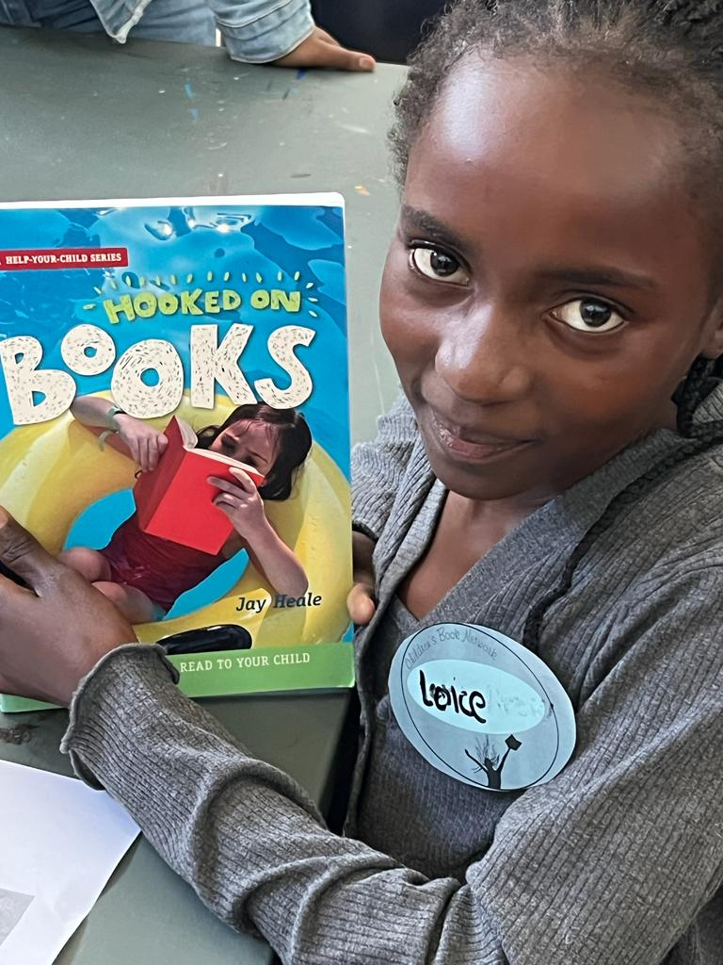

ABOUT US

CBN is a Not-for-Profit (NPO) and registered as such. We receive no support from government, working instead with a series of donors who understand the critical importance of reading for children aged between 10 and 12 – the ages that we work with.

These children have received minimal basic literacy, in their own mother tongue (we have eleven official languages). When they switch to learning in English at age ten, they are not adequately prepared. They cannot read either for meaning or pleasure - in any language.

We do not work with schools – although some schools have welcomed us informally to help redress this imbalance. We work with communities, individuals and organizations who see the desperate need, but struggle to find enough suitable reading materials. In our toolboxes and at our workshops, we provide the kind of reading that children can enjoy and be inspired by – and a trail of interesting texts and books to follow … until they become readers. That is our work. Those children are our inspiration.

***

www.childrensbook.co.za | info@childrensbook.co.za

14 Long Market Street, Stanford, 7210 | P.O. Box 121, Stanford, 7210 | 0826464420

TRUSTEES: Lesley Beake, Anthony Gregorowski, Dave Mohr, Hildegard Witbooi

The Children’s Book Network Trust No. IT20964/2014 | NPO 163-927 |

PBO 930054855 | Section 18A

THE PROBLEM

Reading in South African schools is in crisis. It was desperate when we began a decade ago. Today, it is worse. The most recent international reading report (PIRLS 2021)* put our country third from last out of 57 countries tested. An alarming 82% of children in our schools cannot read for meaning by the age of ten - in any language. This is not going to get better unless some serious effort is put into enabling the most important life skill and educational skill that we have. Reading.

Teaching a child to love reading and books is not difficult. But it does require some basic tools. Books, for one thing. Stories that really reach a child’s heart instead of passing briefly through their minds on the way to a ten-point test that is immediately forgotten. Books that make them think. Non-fiction that expands their knowledge of the world. Words that expand their imagination. Reading that is fun as well as purposeful.

Children’s Book Network (CBN) has been holding reading workshops in rural areas for so long, that we now have a considerable collection of material that ticks all those boxes. Our workshops are voluntary – the children attend them after school or at weekends and in school holidays. They come back again and again – and again. They are *hungry* for stories. In the process of having fun at a workshop, they read an astonishing amount. Their reading gets better. They read more. They imagine more. They think more. They become readers.

*PIRLS Report at: <https://pirls2021.org/results/>

OUR CBN MANTRA:

READ – THINK – READ AGAIN – IMAGINE – THINK – READ

OUR METHOD

* We work in under-resourced, mostly rural areas where there is little support and help for vulnerable readers.
* We are a small organization, working from a spare room and a garden hut. Meetings are around a dining room table. We supply our own equipment.
* We choose themes that will interest children of ten, eleven and twelve.
* We search out books published locally and internationally to expand the theme.
* The books must be relevant, beautiful, and imaginative – and, above all, excellent.
* Within those themes, we offer specially written texts – non-fiction as well as fiction, poetry as well as fun – that expand the theme and make the readers think.
* We add an unobtrusive course on how to read better, a beginner’s writing course and a host of activities, and art projects.

THEN

We offer complete reading privacy and choice. There is no marking, correcting of spelling, monitoring of hand-writing or other obstructions to free and joyful reading. We offer fun and the peace to imagine – to imagine anything at all. We monitor the results in unobtrusive ways, but the best result is the gleam in the eyes of a child who has – at last – connected with the words on the page. A child who can read for meaning as well as fun. A reader.

OUR TOOLS

WORKSHOPS

Our hugely popular workshops are a testing ground for all our written materials - around 800 new and specially created stories, non-fiction texts, poems and songs are collated in themes including topics like bravery, imagination, and environmental issues. Each of these has been written with local children in mind.

In addition, we have a core collection of books on each theme and an extensive collection of books that may be borrowed and taken home to read.

READING TOOLBOXES

It has always been our intention to spread our methods and materials to reach as wide a number of children as possible. Our Reading Toolboxes are the result of years of planning and dreaming. There are three of them:

RED TOOLBOX

Aimed at 10-year-olds. This box contains three book-bags with material on three themes – Books and Stories, Bravery, and Imagination. (25 of these toolboxes have already been donated to organizations working in under-resourced areas.)

GREEN TOOLBOX

For 11-year-olds, the environment is the topic, with five linked themes. During the pandemic, we distributed 100 files of reading material each week for 17 weeks based on the core material for this box.

BLUE TOOLBOX

For 12-year-olds and older, this toolbox challenges with ideas of Time and Landscape. It is currently being trialed and a pilot project developed for rural children in the Tankwa Karoo.

TRAINING PROGRAMME

We offer part-time work to local unemployed people with a view to increasing our workshop capacity. We see this as an important part of our work encouraging reading within families and communities. Several young people have been positively influenced by working with us as volunteers.

SUMMING UP

We are poised to expand our work, both locally, through our workshops, and to a wider platform with our Reading Toolboxes. The need is great and the time for action is NOW!

We are ready.

FUNDING PROPOSAL 2024 -2025

WHAT DOES IT COST? WHAT DO WE NEED?

The toolboxes and the workshops are completely integrated. One informs the other and the material we create for both is the core work of CBN. For funding purposes, we have now divided the costings and incorporated some of the operational costs into each. In addition, we have to seek funding to run the whole operation and to develop further materials that we hope will generate income for CBN in the future.

ANNUAL WORKSHOP COSTS

REGULAR WEEKLY WORKSHOPS:

These workshops are held after school. The workshop average is 15 children

|  |  |
| --- | --- |
| Facilitators (local unemployed women from the relevant communities) | R 400 |
| Printing (including reading packs to take home) | R 250 |
| Stationery | R 50 |
| Providing juice and snacks for the children | R 150 |
| **Total** | **R 850** |
| **Total 3-per week over a 10-week period** | **R 25 500** |

SPECIAL SATURDAY WORKSHOPS:

During these Special Saturday workshops, the average children attending is 35.

|  |  |
| --- | --- |
| Fee for special guest – musician, art, or craft facilitator | R 1000 |
| Facilitators x3 | R 750 |
| Printing and reading packs | R 500 |
| Stationery | R 200 |
| Development cost | R 2 500 |
| **Total** | **R 4 950** |
| **Total 2 per term** | **R 9 900** |

Local facilitators

4 sessions per quarter

|  |  |
| --- | --- |
| Admin costs | R 4 000 |
| Food – a welcome snack and a simple lunch plus apples to take home | R 800 |
| **Total** | **R 4 800** |
| **Total for 4 quarters** | **R 19 200** |

NUMBERS OF WORKSHOPS:

We try to run these regularly if funding permits. If funding runs out – we stop until more comes in. Ideally, we would have, every quarter:

Weekly workshops – 3 per week over a 10-week period

Special Saturday workshops - 2 per term over a 10-week period

Cost of workshops per quarter: R 54 600

Annual costs R 218 400

Admin costs 10% of total = R 21 840

TOTAL ANNUAL WORKSHOP COSTS: R 240 240

COSTING FOR RUNNING CBN

PERSONNEL COSTS INVOLVED MONTHLY

|  |  |
| --- | --- |
| LABOUR |  |
| Concept, Creative development, and writing (Lesley Beake) | R15 000 |
| Activities and project development,  Games and puzzles (LB and WvZ) | R12 000 |
| Administrative assistant (Kelly Semu) | R 2 000 |
| Assembly of toolbox (Kelly Semu) | R 2 000 |
| Additional input from experts (Lisa Witherden, Emily Hallinan, and others)  Peer Review and assessment of material (no cost) | NIL |
| MONTHLY RUNNING COSTS | R 31 000 |
| **ANNUAL LABOUR COSTS** | **R 372 000** |

OPERATIONAL COSTS (ANNUAL)

|  |  |
| --- | --- |
| Rental | NIL |
| Insurance (for workers and children) | R5 000 |
| Book-Keeping | R12 000 |
| Bank Charges | R5 000 |
| Auditing | R6 000 |
| Printing | R12 000 |
| Internet and cellphone costs | R12 000 |
| Stationery including printer cartridges | R15 000 |
| Travel costs | R10 000 |
| Entertainment - including board meetings | R2 500 |
| **ANNUAL RUNNING COSTS** | **R79 500** |

**COST OF RUNNING CBN FOR A YEAR R 372 000 + R 79 500 = R451 500**

*(For reference, the exchange rate for our weakening rand hovers about*

*20 rands to the dollar)*

SPECIFIC COSTS OF RED, GREEN, AND BLUE TOOLBOXES

RED TOOLBOX

This toolbox is ready to go to print. The research and development over a five-year period has been funded partly through unspecified donations (where donor does have particular purpose for their funding) and mostly by volunteer work by many people from different fields of interest. Lesley Beake was the driving creative force behind the whole concept and received remuneration when this was possible.

*NOTE: The deficit in both 2021 and 2022 comes from invoices from LB that were not paid during those financial years.*

MATERIALS PER TOOLBOX

|  |  |
| --- | --- |
| Cost of caddy to present the whole package | R 1 500 |
| Cost of book-bags and stationery | R 500 |
| Cost of included books  (Between 40 - 60 books per box) | R 6 000 |
| Printing of handbooks | R 1 000 |
| Cost of assembly and shipping | R 1 000 |
| **TOTAL PER BOX** | **R10 000** |

WHAT WE NEED

Our next task is to market and promote the Red Toolbox to organizations and entities who may subsidize donations to schools, libraries and projects who can make full use of the material and extend its reach. This is a big job requiring time and patience and money.

Estimated cost R20 000

Assembly of boxes, ordering of books etc. annually R12 000

Administration of toolbox distribution and setting up systems annually R12 000

OUR GOAL

50 Red toolboxes donated by February 2024. A further 200 by end 2024

COST

50 X R10 000 = R500 000

Admin costs of R24 000

TOTAL COST OF 50 RED TOOLBOXES R524 000

GREEN TOOLBOX

A project for 2024-2025

The material for this box has been partially developed for our Lockdown Learning project during the pandemic. Costing for the materials will be similar (allowing for the steep increase in cost of living). Development costs to bring the whole thing to completion: R100 00O.

BLUE TOOLBOX – a special case

This toolbox – the most complex of all, aimed at 12 – 15-year-old children has been developed with external funding as part of a bigger archeological outreach project. The basic material will be complete by end of February 2024 when our financial year ends, and we will then need funding to buy books and other materials to complete the toolbox. Estimate: R100 000

HOW CBN CAN GENERATE FUNDING

CBN will always be dependent on funding from donors, but it is our intention to raise money through the toolboxes on a percentage basis of each toolbox donated. Branding of donated toolboxes is also possible.

We already have first orders for donated Red Toolboxes and a strong initiative on the Blue Toolbox where a book *(The Time Trackers)* is in the process of publication and the relevant Book-Bag almost complete. The *Poppy* Books continue to bring in small amounts of funding, but need more active publicity.

Our need is great – so is our hope for the future.

***

Lesley Beake (Director) [lesley@lesleybeake.co.za](mailto:lesley@lesleybeake.co.za)

Stanford, August, 2023

Children’s Book Network [www.childrensbook.co.za](http://www.childrensbook.co.za)

***

HOW TO DONATE:

*Bank details*

**Account Name:** The Children's Book Network Trust

**First National Bank:** Tokai Branch

**Branch number:** 200409

**Account Number:** 625 70 830 458 (Cheque account)

**Swift code**: FIRNZAJJ

*Givengain*

GivenGain is a safe and secure online platform to make donations to Children’s Book Network, from anywhere in the world.

You can find our GivenGain profile here:

<https://www.givengain.com/cause/7204/>

*Sable Forex*

Transfers can also be arranged through international financial advisors *Sable* for long term donations.

WEBSITE [www.childrensbook.co.za](http://www.childrensbook.co.za)

Links to more information about the Toolboxes and Reports

TRAINING PROGRAMME

<https://www.childrensbook.co.za/2022/09/26/training-programme-for-local-facilitators/>

|  |
| --- |
|  |
| |  | | --- | | [What are Toolboxes For? - Children's Book Network](https://www.childrensbook.co.za/2022/09/26/what-are-toolboxes-for/)  [childrensbook.co.za](https://www.childrensbook.co.za/2022/09/26/what-are-toolboxes-for/) | |

TOOLBOXES

What, exactly, is a CBN Toolbox?

<https://www.childrensbook.co.za/2022/08/22/what-exactly-is-a-childrens-book-network-toolbox/>

WORKSHOPS

<https://www.childrensbook.co.za/category/workshop-reports/>

***