ANNUAL REPORT 2022 - 2023

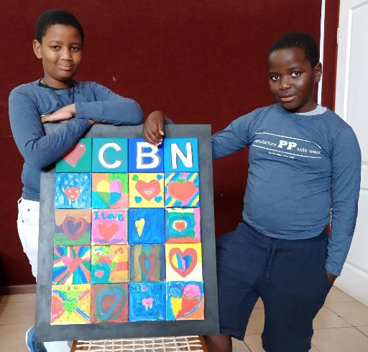

The world has changed immeasurably. In the ten years we have already been engaging with children and reading, everything has shifted in sometimes life-altering ways. The children we work with now, are not the same as the children we worked with then. Reading has become a critical life-skill as well as a desperate need.

It is time to re-define what we mean by the word children, and what we hope for with the word reading. It is no longer enough to dream that the young people we work with will simply read for pleasure, that reading will bring them respite from a challenging environment and escape into somebody else’s world. They need to read and after that, they need to think.

Our focus has never been on the younger children who need (is there no stronger word?) HAVE TO HAVE basic literacy and the ability to decipher marks and symbols on a page. Some of them are achieving that by the time they are ten, but not enough of them. The figures indicate a perilous national failure in education in South Africa. Only 18% of our children measured in the International Reading Literacy Study (PIRLS), can read for meaning at the age of ten (by the time they reach grade four). To put that another way, 82% of them cannot. And grade four is, in many ways more challenging that the final year of schooling (if they ever reach Grade Twelve).

Statistics from the Progress in International Reading literacy (PIRLS)
www.nces.ed.gov/surveys/pirls/

In Grade Four they move from being little children. They have to understand big issues like the shape of the world and the sciences of life. They have to build the basic blocks of knowledge of history and geography and how those, and many other, disciplines, affect them and their families and their communities. And they have to do this in English, which is not the language they can speak and communicate in at home. They must do this with very little help. Over-stretched teachers struggling with an overwhelming burden of evaluation and administration seldom have time to address the needs of additional literacy. Young people should be able to read already. Shouldn’t they?

Add to that, the acute shortage of anything interesting to read, and you drive everyone (teachers included) towards an easier option. Social media and any other medium involving screens present a more comfortable alternative. One that is quick, and short – and one that, with a movement of only a finger, can be adjusted to a level of comfort that encourages involvement. Who needs books?

Well, we believe that all of us need books. Perhaps more to the point, we need the ability to read with comprehension, understanding and imagination – whether it be with books or on a screen. Critically, we also must be able to THINK about what we read.

Children need this too.

All the materials in our workshops and toolboxes are written or collated to produce this result. We challenge with surprising and unexpected stories and non-fiction. We encourage with activities that involve thinking and creativity. We offer young people a choice in what they think and read and write. Reading freedom.

It isn’t that difficult. Once the initial research has been done and materials have been assembled into a practical format, once the channels of communication have been opened with educators and administrators, we could provide a helping hand to navigate over the rocks of reading reluctance and apathy. We have modified our original goal. We want to help children to read and – most of all – to imagine and THINK about what they read.

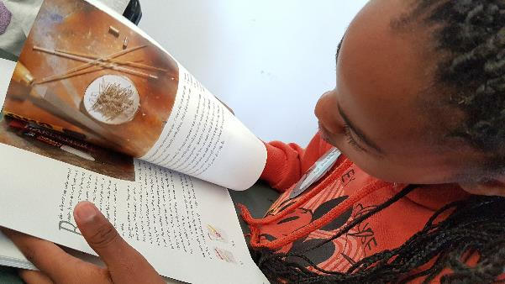
CHILDREN

The children we work with now were six or seven when the pandemic closed down their world. It affected them profoundly – as much, or more, than it affected all of us. As most of us have been able to do, they have adapted and moved on. But, for a year or more, their education came to a near full stop inflicting damage that no recovery plan in the world is ever going to undo.

In other ways too, they live with uncertainty and anxiety that news headlines and reality shows do little to assuage. If ever there was a time to promote reading, it is now.

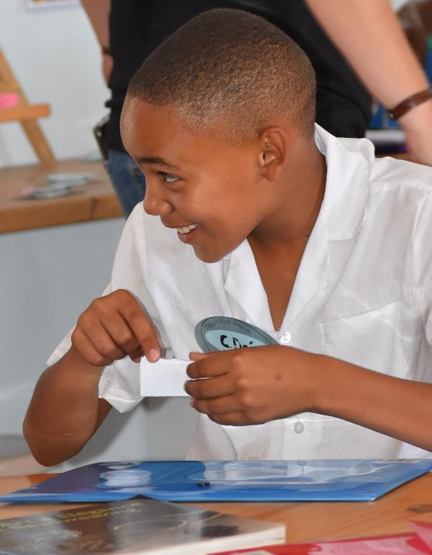

READING

In children’s choices, we have seen a dramatic swing towards non-fiction as well as story. (After all non-fiction often fits into the category of: ‘you couldn’t make it up.’) A combination of fact and fiction with interesting activities and no judgement (as in ‘your handwriting is too untidy’), gives children freedom that leads to interesting thinking, interesting questions in workshops, and a hunger for more. CBN engages with this hunger in three ways:

- WORKSHOPS

More than 667 children have attended our workshops during the last year, all of them excited, all of them giving up free time, all of them completely absorbed in the topic of the day, which could be anything from car design to stone-age microtools. In fact, we have changed from a one-workshop plan to a double involvement, two workshops on the same theme, with a reading pack to take home for rereading plus additional material. They read and read, moving smoothly between poetry, illustration, fiction, non-fiction text and creative thinking. This new approach is working and is further backed up by …

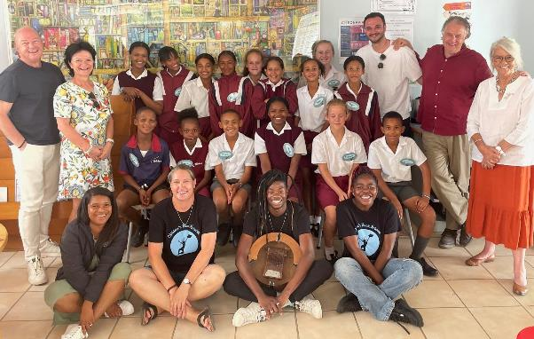

- TOOLBOXES

Workshops are reading laboratories to test out our new and existing reading material in the Reading Toolboxes. There are three toolboxes, spanning three reading years and designed to be used as an out-of-school activity that reinforces what they need to learn – and adds a bit more.

RED TOOLBOX – THEME: BOOKS AND STORIES

Focuses on the youngest children we work with, introduces them to the excitement of story and the beginning of reading for information. (And thinking about what has been read.) This toolbox is complete and ready to roll further into the world of reading.
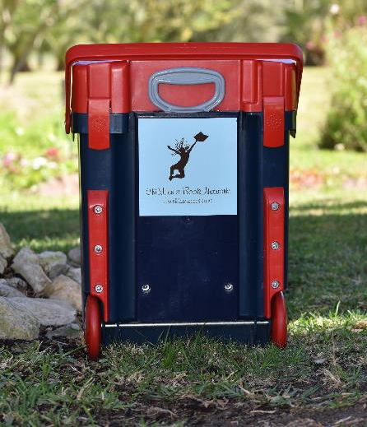
Themes: Stories
Bravery
Imagination

GREEN TOOLBOX – THEME THE ENVIRONMENT

The emphasis is on our world and the marvels we find on it – if they are still there. With a strong conservation ethic. Non-fiction is the backbone of the stories, activities, and imagination in this toolbox. The content for this box was researched and compiled during our Lockdown Learning project, which reached 100 children every week for nearly a year with reading packs that they could share with siblings. (Toolbox still in development.)
Themes: Animals
Caring for our Earth
Ecosystems
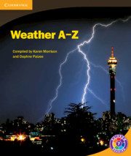
Environment
Fun

BLUE TOOLBOX - TIME AND LANDSCAPE

A challenging dive into the biggest concepts of them all, this one is deeply thought provoking and involves real critical thinking and involvement. (To be trialed in August 2023 in the Tankwa Karoo.)
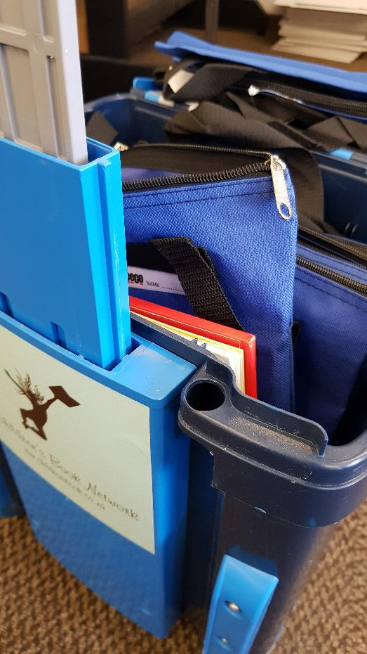
Themes: Imagine the World
Africa and Life
Tankwa
Early people
San

MATERIAL IN THE TOOLBOXES

Each box contains around fifty reading books and 15-20 topic-specific published books (varying according to availability).

The handbook attached to each theme contains around 150 pages of stories, non-fiction and poetry specially written for this project. There are short quotations from many books, but the bulk of the material is original and copyright rests with CBN and Lesley Beake.

There are some wonderful books in our book collections, and the themes have stimulated huge interest from children who do not normally read outside textbooks.

- BOOK BOXES

Once children have been led towards the idea of reading, they can access one of ten carefully curated book boxes (mini libraries), that circulate within our local communities – and are heavily used. We can evaluate the reader’s reading progress by monitoring the books that they choose.
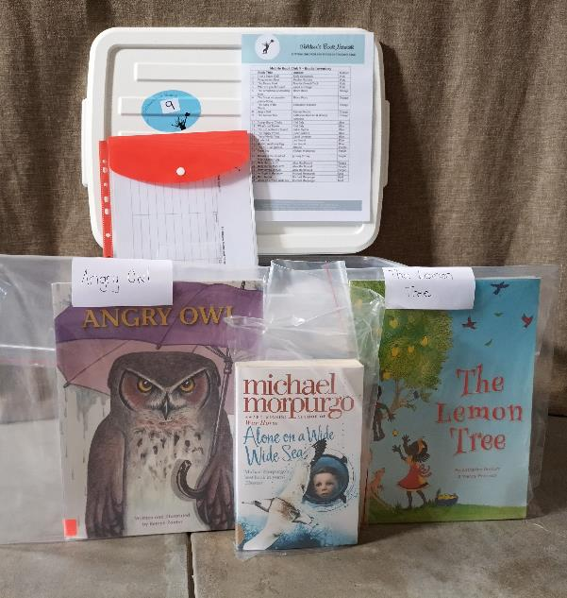
There are currently 10 Mobile Book Boxes circulated in Stanford South. Once the children have worked through the box, the facilitator contacts me and I swop it for a new box.

BOOK DASH

Book Dash generously donate books to us every year. We distribute them under the CBN children and other local institutes. Their motto is, that each child OWN 100 books by the age of five.
The other institutions that we distributed it to was:
Hoopland Academia
Fynbos Academia
Foundation for Community Works
The Learning Tree
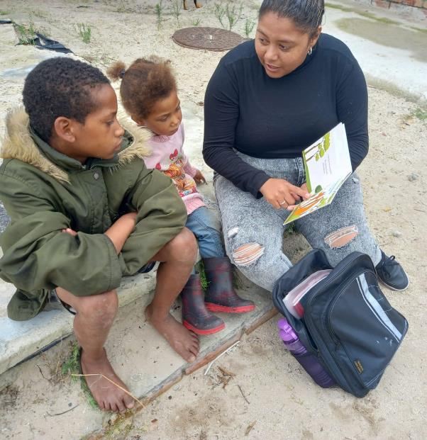
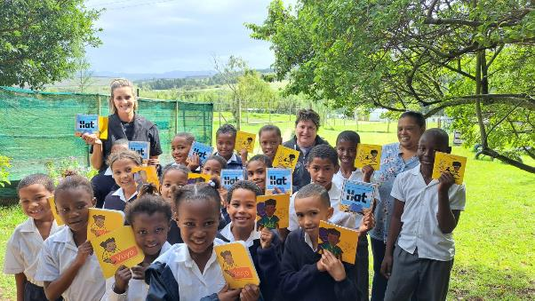

BOOK-BOOKS

This is a (totally private) reading and writing journal linked to the work in the workshops and toolboxes. Children often choose to read their work aloud, but they don’t have to. Their work is not marked or criticized but encourages free imagination and creativity.

TRAIN THE TRAINER

During 2022, we initiated a programme where three local facilitators were given basic skills training and an incentive to hold workshops in their community. This has been facilitated by Creative Skills Workshop, an NGO that works closely with both of our local schools. We now have a fully trained facilitator in Hermanus (Kelly Simu), who will shortly be training more trainers in Zwelihle and Mount Pleasant communities. (And who additionally acts as back-up in the office and maintains the website.)

Rachel van Rooyen and Georgette Plaatjies

Kelly Simu

CONNECTIONS

We have given workshops during this year at the local schools and the municipal library, which have all welcomed us to give after-school workshops.
We have also given successful workshops at Enlighten Educational Trust in Zwelihle (Hermanus) and hope to be working with other projects during 2023, including one teaching life-skills to vulnerable young women in Mount Pleasant and Zwelihle during July.

FRUSTRATION

We are struggling to push forward from this existing reading platform. Time is the biggest problem. There is so much to DO every day – and not enough people or hours in the day.

Funding is, of course, the other problem (and a huge cause of worry). We ideally should be planning ahead, fixing workshops in advance, commissioning illustrations for the toolbox handbooks, working with fresh new voices and skills. Training more facilitators. Developing and growing. For the sake of the children, we need to be able to do this – at any cost.

*
THE TEAM

Lesley Beake is the Director and, by default the fundraiser. More usefully, she also writes the material we use in all our activities.

Wilien van Zyl is the structure behind the ideas, deeply involved, a marvelous organizer and communicator, she connects with the schools, the facilitators, the community and – above all – the children.

Diana Parker keeps the books for us, keeps us on track – and keeps doing this as a volunteer. We thank her more than we can say.

Terry Takura not only enraptures the children with his engaging personality and skill as a musician, but he is also a board member and part of the team that will bring recorded stories to our website. His band colleague Emmanuel, the ever smiling, assists.

John Chancey maintains our website, develops audio-visual materials, offers technical help, and collaborates with ...

... Kelly Simu, the most recent addition to our team, maintains the website, assists with admin, and has now trained as a facilitator who will enable further community members to give workshops themselves.

NOTE: All of the above are part-time and give freely of additional time when needed.

WORKSHOP REPORT

Quarter | No. of workshops | No. of Children reached
First: March – May | 24 | 299
Second: June – Aug | 15 | 159
Third: Sept – Nov | 11 | 123
Fourth: Dec - Feb | 6 | 86
TOTAL | 56 | 667

In the financial year of 2022-2023, we are very satisfied with our number of workshops and the amount of children we reached. It might seem much lower than the previous years, but we focused on quality and not quantity at the workshops.

We successfully trained two facilitators from Stanford South. Creative Skills (Regina Broenner) have generously gave us permission to use their premises The Leaning Tree, in Stanford South. We had a couple of workshops there in November, which the facilitators, Rachel van Rooyen and Georgettte Plaatjies, ran.

Unfortunately, we had to put a hold on those workshops for January and February 2023, due to finances. After receiving some funding in February we continued with the workshops in March 2023.

Last year, 2022, we facilitated workshops on Monday’s at Okkie Smuts and Wednesday’s at Die Bron school. This year, 2023 we will still have workshops on Monday’s at Okkie Smuts. The Wednesday, Die Bron workshops will be cover by the facilitators in Stanford South, on a Thursday afternoon.

We are looking forward to the 2023 workshops and all the reading that’ll be done!

THE NUMBERS (Diana Parker and Hermanus Auditors.)

IN SUMMARY …

We work with the age group 10 to 12 and older
We add to existing reading early literacy taught at schools
We present reading as an essential life-tool as well as a pleasure
We promote the idea of involvement and thinking about exciting topics
We are non-judgemental, non-intrusive – we point the children in directions …

AND LET THEM READ, WRITE, THINK, READ AGAIN AND
ABSORB CREATIVE IDEAS

Lesley Beake
Stanford
10 April 2023

‘Don’t just read, watch us on a screen as well!’

https://youtu.be/HOVEQwnK76A
