CHILDRENS BOOK NETWORK – 10 years of reading

ANNUAL REPORT 2021 - 2022

INTRODUCTION

We sometimes forget that this gigantic task will never go away. We are now looking at a fifth generation of ten to twelve-year-olds reading with CBN. Some of the first children we worked with have children of their own. It would be wonderful to think that they remember that reading can be fun, that reading can be everything to a child and are passing on the idea.

Nothing has changed about our goals and aims. We still want to bring books to children – and a love of reading – that can change their lives and futures. WE haven’t changed. But the children have.

In our ten years of existence, we have seen three huge changes in the lives of children in South Africa, but in many cases also globally.

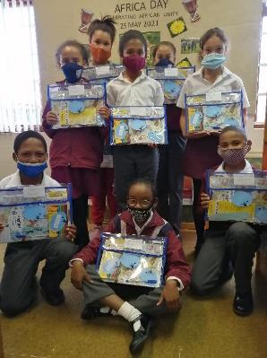

1
The dumbing down of education as offered in average South African schools. (There are wonderful exceptions, but the mythical ‘average South African child’ isn’t at them and is not enjoying the skills of some of our truly exceptional educators.)

The current curriculum places a strong emphasis on conformity. ‘The facts’ must be covered in a very short time, and there are so many facts to absorb, or at least to have seen briefly in a textbook. The focus is on being able to assemble these facts again in tests and evaluation. There is a crying need for imagination and passion in the lives of children who learn to read – but don’t read. They need books. They need to be able to imagine the worlds of other people and other places.

2
MULTIPLE MEDIA AND HEAVY INFORMATION OVERLOAD.

Children’s attention span narrows every year we work with them. This is a global phenomenon and applies to adults too. To catch children’s interest, reading must deliver quickly and not challenge them too much – and this also leads to a shortage of creativity and – most of all – lack of imagination.

3
COVID

Not enough has been said about the effects of the pandemic on the lives of children. Estimates are that they have lost, on average, 1.3 years of education during the last two years. How can they ever catch up again? (Answer: They can’t.)

CONCLUSION

Now, more than ever, they need reading. We see it as the only survival skill that can help them out of this mess. If they can read, they can do anything they set their minds and hearts to do.

***
OUR CORE FUNCTIONS REMAIN …

WORKSHOPS

Wilien continues to give workshops to children in Stanford South with Stanford Library workshops weekly. We also give regular workshops at De Bron and Okkie Smuts Primary Schools, and we have started of a programme at Enlighten Trust (Zwelihle). At De Kop some children work at home and some with Vuyo at the community hall in the informal settlement. We were recently given permission by the principal of De Bron to arrange workshops on Saturdays as well as after school.

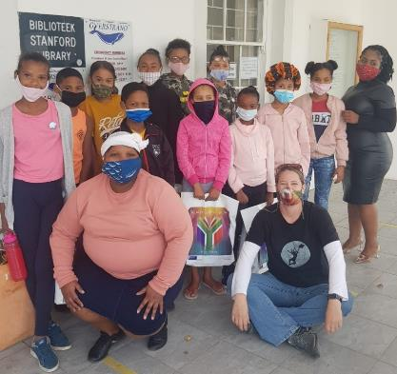

De Kop informal settlement:
Vuyo Siza, after five years with CBN, is now working full time at The Butterfly School (for children with special needs), as well as working with the choir on other music projects. The De Kop workshops have been suspended for now – but the children living at De Kop attend De Bron and Okkie Smuts schools and are in our catchment area there. We need to thank her for all her efforts with our Lockdown Learning programme, which she ran with efficient dedication.

Zwelihle (Enlighten Educational Trust) We have already begun a series of workshops there and will start the new season in March, hopefully with Terry Takuma and Inge Mafuzi as facilitators.

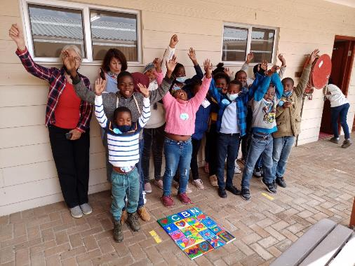

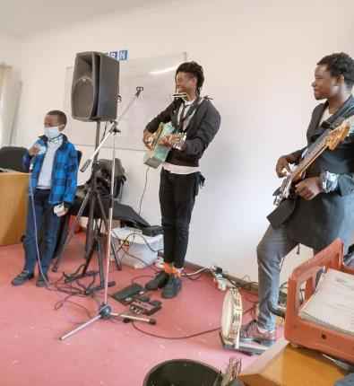

WORKSHOP REPORT 2021 - Wilién van Zyl

26 February 2021 was our first meeting with the children of De Kop since Covid 19 lockdown started in 2020. This was not a formal workshop just a meet and greet to assess the feelings among the children. We realised that the children had definitely changed since we last saw them for a workshop.

They were less spontaneous and not very reactive towards us and the facilitators. The next workshop, on the 23rd of March, we did reading, writing and painting on canvases. The children enjoyed it, but their attention span was very limited.

After these experiences, we decided to have smaller workshops, more regularly, with groups of 10-12 children, to stay within the Covid 19 protocols.

We used four venues for the workshops, De Kop, Stanford Library, Okkie Smuts School Library and Die Bron School Library. We were very excited to form a bond with Stanford Library and to use the town library as a venue for our workshops.

Workshops that stood out this year were our art workshop, with Stanford artist Marian Binder. We used the Stanford Community Hall, to have lots of space to work and play. The theme was I love Stanford. All the children got a 4x4 canvas to create their own heart that would be presented into a collage of hearts.

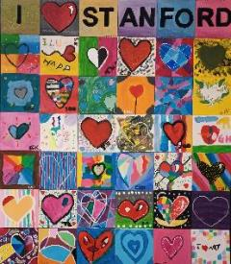

The second, was a music and art workshop at Enlighten Trust with Terry Takura, the local Hermanus musician. With the help of Terry the children created a CBN song. The children enjoyed the music, tremendously! After the music session the children created their CBN heart 4x4 canvas’s. A great deal of reading also went on!

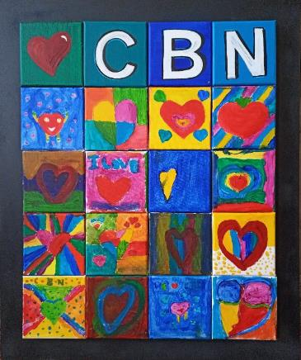

It is difficult to have stats as in the previous years. A ball park figure would be best for 2021. We reached 3026 children through 178 small workshops.

We are looking forward to 2022!

TOOLBOX REPORT – Lesley Beake

RED TOOLBOX

The Red Toolbox is finished! Well not finished, exactly. It still needs professional editing and some illustration, proper design and layout and printing. But the text is written. The multitude of stories, poems, ideas and activities are safely stored on a hard drive (and elsewhere) and copies of the three handbooks (each of over 100 pages) have been printed and distributed for peer review.

The Main topic of this box is Books and Stories, aimed at the youngest level we work with (Grade 4 or 10-11 years-old). We are trialing it with children at the local schools and it remains a constant resource for all the work we do.
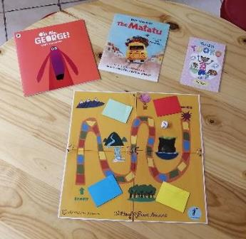

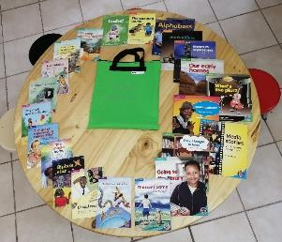

GREEN TOOLBOX

This was the focus of our Lockdown Learning project in 2020 when we handed out 100 reading packs every week to our core group of children. These were shared with siblings and the result was a massive reading outreach to children who were not permitted to attend school during lockdown, who were bored, frightened and traumatized.

This work needs revision and organizing into the Toolbox format, but it also serves as a resource when we need it. (Aimed at Grade 5, the 11–12-year-olds.)

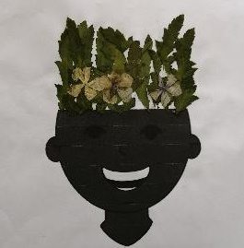

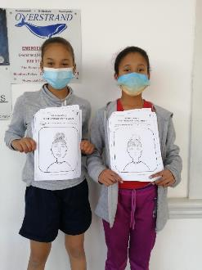

BLUE TOOLBOX

Time and Landscape is the most difficult, the most challenging and the most fun. The writing is more than half-way done and the organizing of material and books complete. We will be trialing this in the Tankwa Karoo (one of the least inhabited bits of Africa), in August as part of an Archaeology outreach from UK, America and Portugal. This one MUST be finished, as there are possibilities for funding of this through other outreach programmes concerning Archaeology, History and deep time. (Aimed at Grade 7, the 12–13-year-olds.)

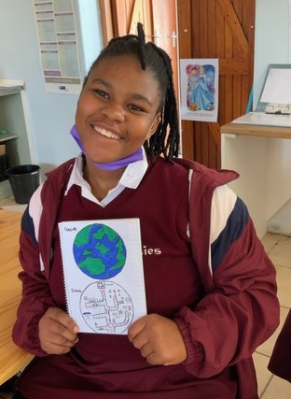

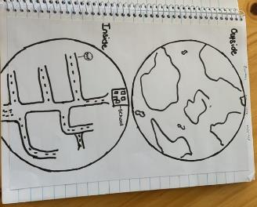

BOOK BOXES AND BOOK CLUBS - Wilién van Zyl

We are happy to report that we have nine Book Club Boxes in circulation.

The locations are as follows: Two in De Kop, two at Hoopland School, one at Julbelland aftercare centre, two in Stanford South (run by a mother), one at the library workshops and one in Zwelhle (Hermanus).

The Mobile Book Club container contains the following:

- 25 story books
- A book title and author list of all the books
- A register that will indicate the name of the child, the title of the book that was borrowed, the in and out date of the book and a rating of the book 1-5 when it was returned.
- ALL our books come back for exchange with another!

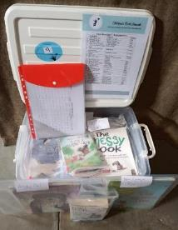
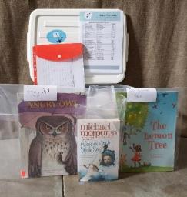

We have had generous donations to buy books, and books that were donated to us by various people. All these books were graded by colour coding to provide a couple of books for each reading level. CBN bookmarks are included in each box for children to keep and to use while they read the books at home. The feedback from the different facilitators was all positive. The average number of children that make use of a box is 20. We are very excited that we can provide this service to our community.

By the end of the second term we will rotate the boxes between the various facilitators, so that the children will have the have the opportunity to read new books each term.

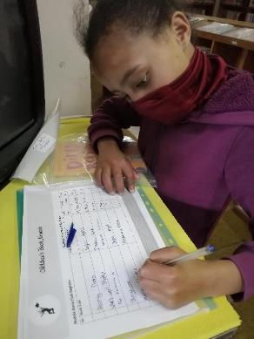

This was always a goal as an extension of, and back-up to, the workshops.
Our nine Book boxes circulating Stanford South and De Kop are an integral part of our efforts.

REBRANDING AND UPGRADING COMMUNICATIONS

It became essential to upgrade the website for two reasons:

- Our old site was never cellphone compatible.

- CBN needed a fresher image – although this was only supplementary to the first, and second, main, reasons.

- Critical for fundraising, this upgrade was beyond our in-house skills and has to be outsourced. Octopi Communications – who gave us special social responsibility rates to bring us up to a fresher, more modern look.
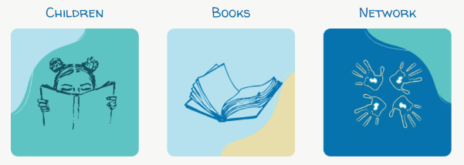

SOCIAL MEDIA

Penny Louw joined us this year as an effective communicator. She and Wilien share the task of keeping our friends up to date.

MANAGEMENT

We desperately need an additional staff member, particularly in the areas of fund-raising and materials creation

JOB CREATION

A priority for 2022 is to create part-time jobs for local people as facilitators for workshops, community contacts for running book-boxes and outreach programmes. We are aiming at training three part-time people – four would be better.

SUSTAINABILITY

The plan has always been that we would create income for CBN through the toolboxes. We have also initiated a small publishing project. Proceeds from this will go entirely to CBN after coats. The first book (Poppy) will be available in first quarter next year. We hope sales from that will generate income.

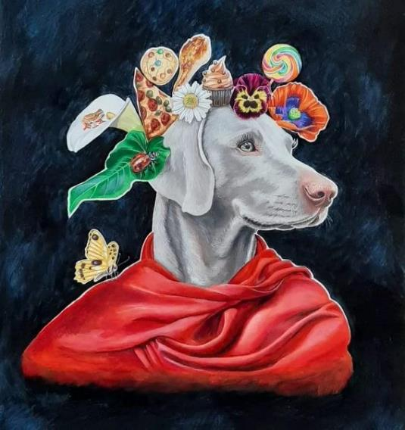
CHANGE

Due to the pandemic, we have had to change our methods. Technology has also caught up with us, and the attached budget reflects some of these changes as well. We have dismissed several ideas as impractical in the circumstances, but the following remain crucial.

DEVELOPMENT OF MATERIALS THAT CAN BE SHARED.

We are reaching a large number of children – but only in the Overberg. At the end of 2021, we are stretched to capacity. The toolboxes remain the most effective means of making a jump into a larger community.

We already have toolboxes in other areas, namely Mitchell’s Plain (8 toolboxes) Eastern Cape (2 Toolboxes) and Western Cape (a further 12 toolboxes).

We were just launching a training programme in Mitchell’s Plain when Covid put a stop to further development.

Future plans include looking for a sponsor for the toolbox programme that will be big enough to cover the considerable costs involved in rolling out this programme.

We are ready to go. We just need to find the funding!

***
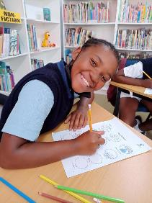

SUMMARY OF COSTS
(Audited financial report can be found at www.childrensbook.co.za)

WORKSHOPS and BOOK BOXES R 113 710.00

TOOLBOXES R 3 540.00

WEBSITE AND MATERIALS DEVELOPMENT R 107 012.00

OTHER COSTS

THIRD PARTY INSURANCE TO PROTECT CHILDREN

R 5 738.00 per year

RENT

None. We use public venues for workshops. A hut was kindly donated (by William and Penny Lowe when our venue was sold). The CBN Book collection and the CBN office is housed at Lesley’s home.

TECHNOLOGY

We have a donated data projector, printer, and scanner (which is currently being replaced due to overwork!). William and Penny Louw generously donated an iPad Pro, which is absolutely invaluable, in a hundred ways, but particularly at workshops.

ACCOUNTING, BANK CHARGES AND OTHER COSTS

Accounting and Auditing annual costs R 8 630.00
Communications – phone and Internet R 130 088.00
Entertaining – Board and staff meetings R 5 540.00
Bank charges R 5 988.00

DONORS AND FUND-RAISING
Full list available on request.

Our heartfelt thanks to all who support us in so many ways!

Lesley Beake
Wilién van Zyl

30th March 2022
Stanford

